ASSIGNMENT-1.1

Name: chilukamari bhavya Hall-Ticket No: 2403a51109

Batch No: 06 Course: AI Assisted Coding

Task 0

* Install and configure GitHub Copilot in VS Code. Take screenshots of each step.

Expected Output

* Install and configure GitHub Copilot in VS Code. Take screenshots of each step.

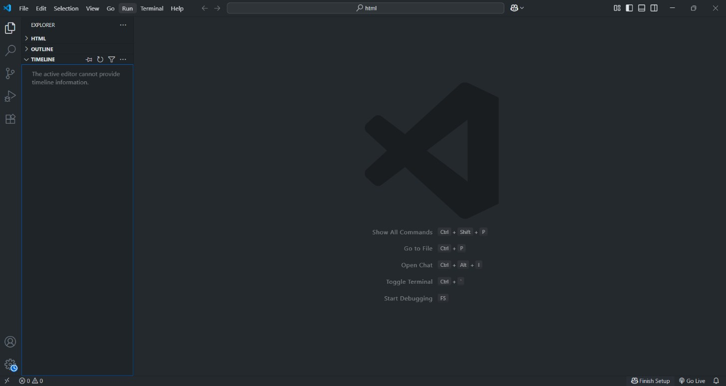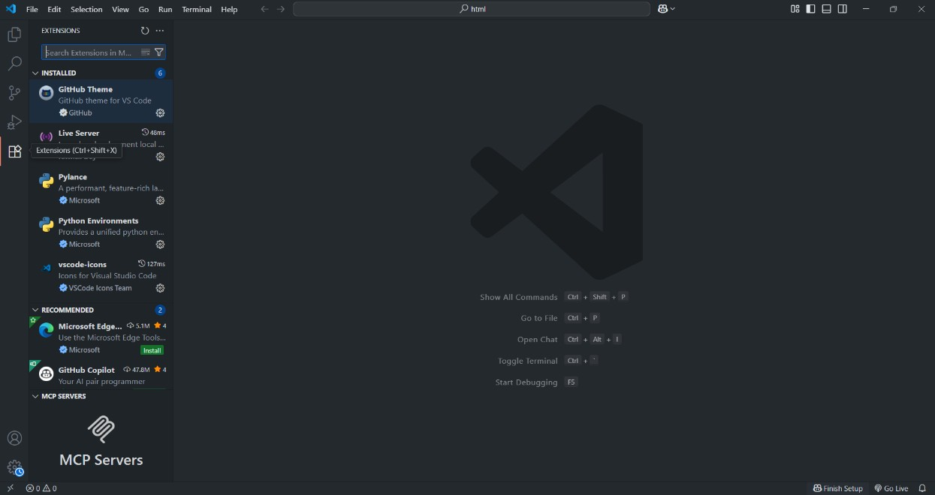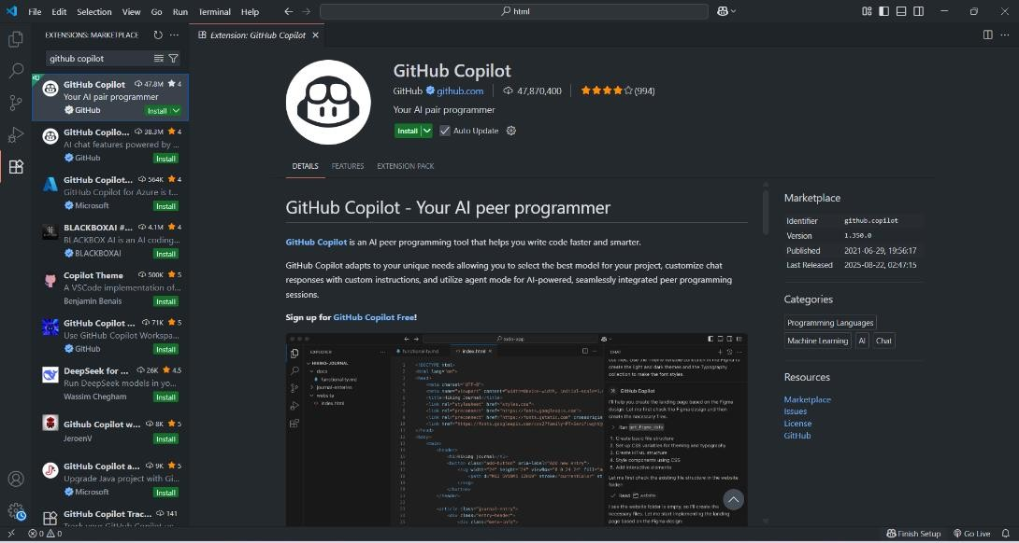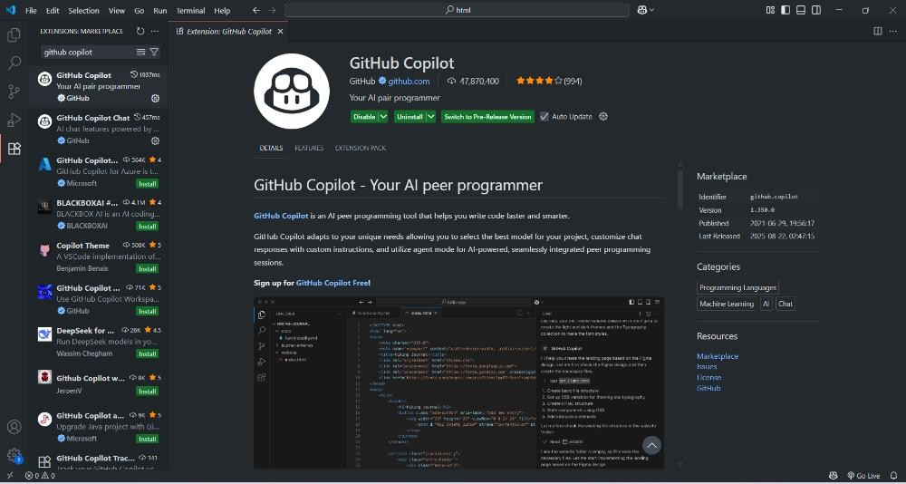

Task 1: Factorial without Functions ● Description:

Use GitHub Copilot to generate a Python program that calculates the factorial of a number without defining any functions (using loops directly in the main code).

* Expected Output:

o A working program that correctly calculates the factorial for user-provided input. o Screenshots of the code generation process

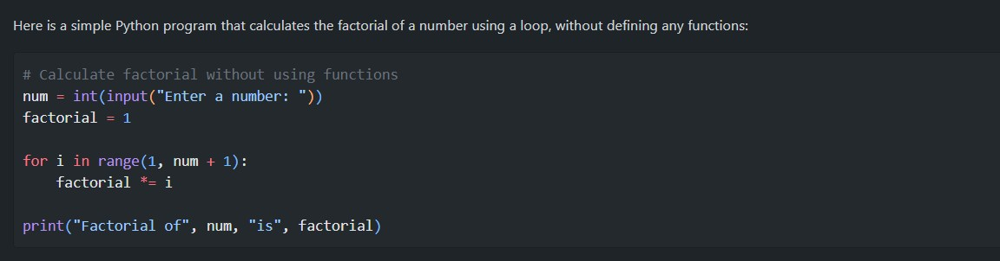

Output:

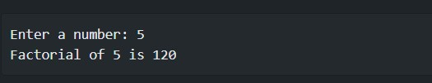

Explanation:

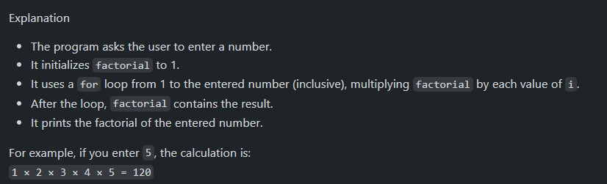

Task 2: Improving Efficiency ● Description:

Examine the Copilot-generated code from Task 1 and demonstrate how its efficiency can be improved (e.g., removing unnecessary variables, optimizing loops).

* Expected Output: o Original and improved versions of the code. o Explanation of how the improvements enhance performance

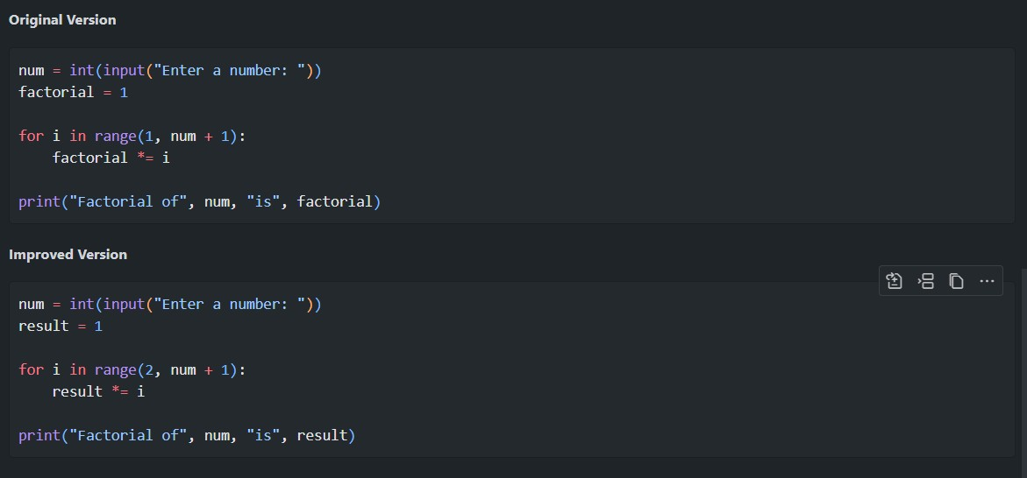

Explanation:

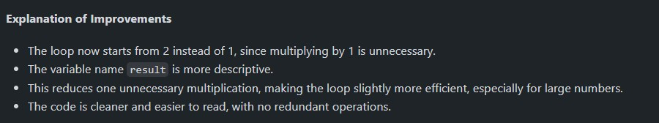

Task: Factorial with Functions ● Description:

Use GitHub Copilot to generate a Python program that calculates the factorial of a number using a user-defined function.

* Expected Output: o Correctly working factorial function with sample outputs.

o Documentation of the steps Copilot followed to generate the function.

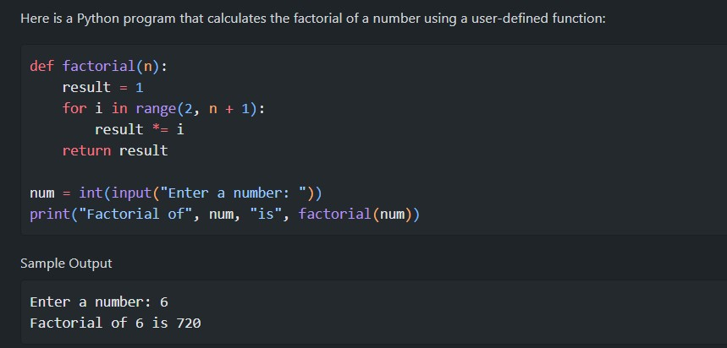

Explanation:

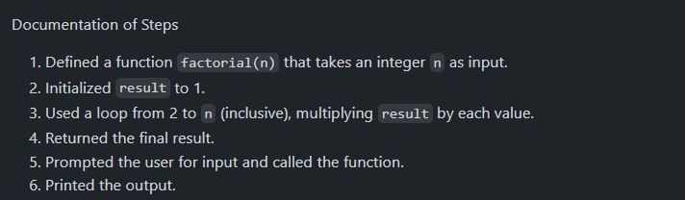

Task4: Comparative Analysis – With vs Without Functions ● Description:

Differentiate between the Copilot-generated factorial program with functions and without functions in terms of logic, reusability, and execution. ● Expected Output: o A comparison table or short report explaining the differences.

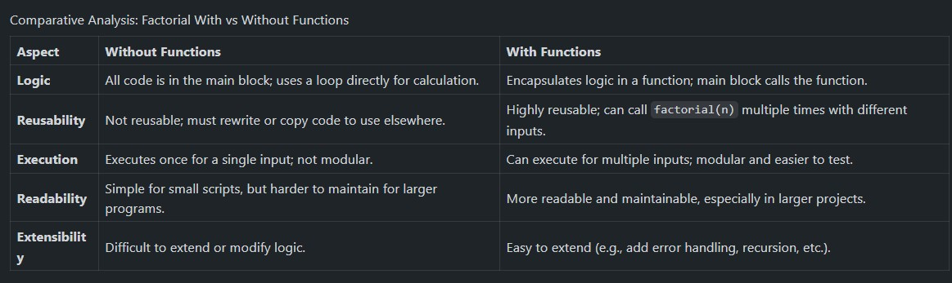

Task5: Iterative vs Recursive Factorial ● Description:

Prompt GitHub Copilot to generate both iterative and recursive versions of the factorial function.

● Expected Output: o Two correct implementations.

o A documented comparison of logic, performance, and execution flow between iterative and recursive approaches

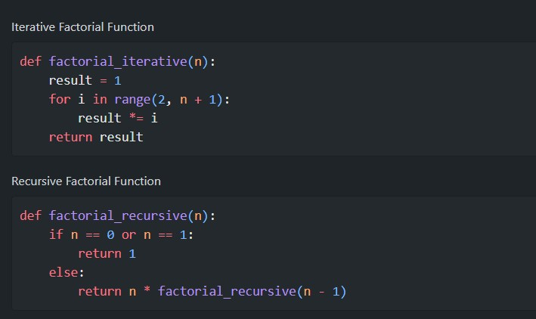

Comparison Table:

